**YELLOW ARCHANGEL TREATMENT IN THE URBAN FOREST**

**An herbicide will be applied to yellow archangel (YA) on Thursday, December 3, 2020. The date may change if rain causes treatment delays. Portions of the Urban Forest (UF) trail will be closed during herbicide application and as a precaution for an additional 24 hours thereafter.**

Background:

The sale of yellow archangel (YA) is prohibited in Washington. YA is banned because it is a non-native, fast growing, dense, aggressive, and mat-forming groundcover that threatens Pacific Northwest forests. This twining plant grows year-round in western WA and as it out-competes and denies sunlight to low growing native plants YA becomes a monoculture across the forest floor (see picture). Native wildflowers are crowded out and low growing native plants are covered over. This plant provides little or no appropriate food or shelter for native wildlife.

One reason this plant is so aggressive is because abundant, thread-like roots (see picture) grow wherever the stem touches the ground. Cutting, pulling, or smothering doesn’t kill it. Leaving minor pieces of stem or root will just start another infestation. In addition these flowering plants release seeds which sprout to form new plants.

Yellow archangel most likely has been dumped onto Lakemoor Community Club common property and now the Urban Forest is infested with significant patches of it. According to experts the UF committee has consulted with, herbicide application is the most effective method, both in time and effort, of removing patches of this tenacious plant. Herbicide treatment will be required over several years.

Sound Native Plants, Inc. has prescribed using a mixture that is state and federally approved for use in both uplands and wetlands. The herbicide mix is triclopyr (acid formulation) and glyphosate along with a vegetable base additive that improves herbicide effectiveness. A dye is added to the mixture to indicate where the state licensed applicators have and have not sprayed.

**Citations / References:**

<https://your.kingcounty.gov/dnrp/library/water-and-land/weeds/Brochures/Yellow_Archangel_FactSheet.pdf>

<https://www.nwcb.wa.gov/weeds/yellow-archangel>

~~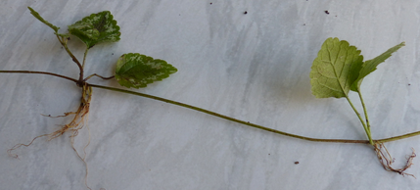~~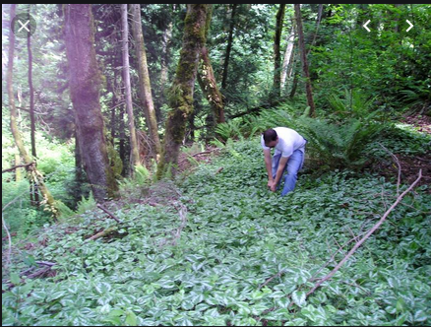 Monoculture of YA in a forest Stem nodes with roots